Total spent time by Md Farukul Islam Project manager.

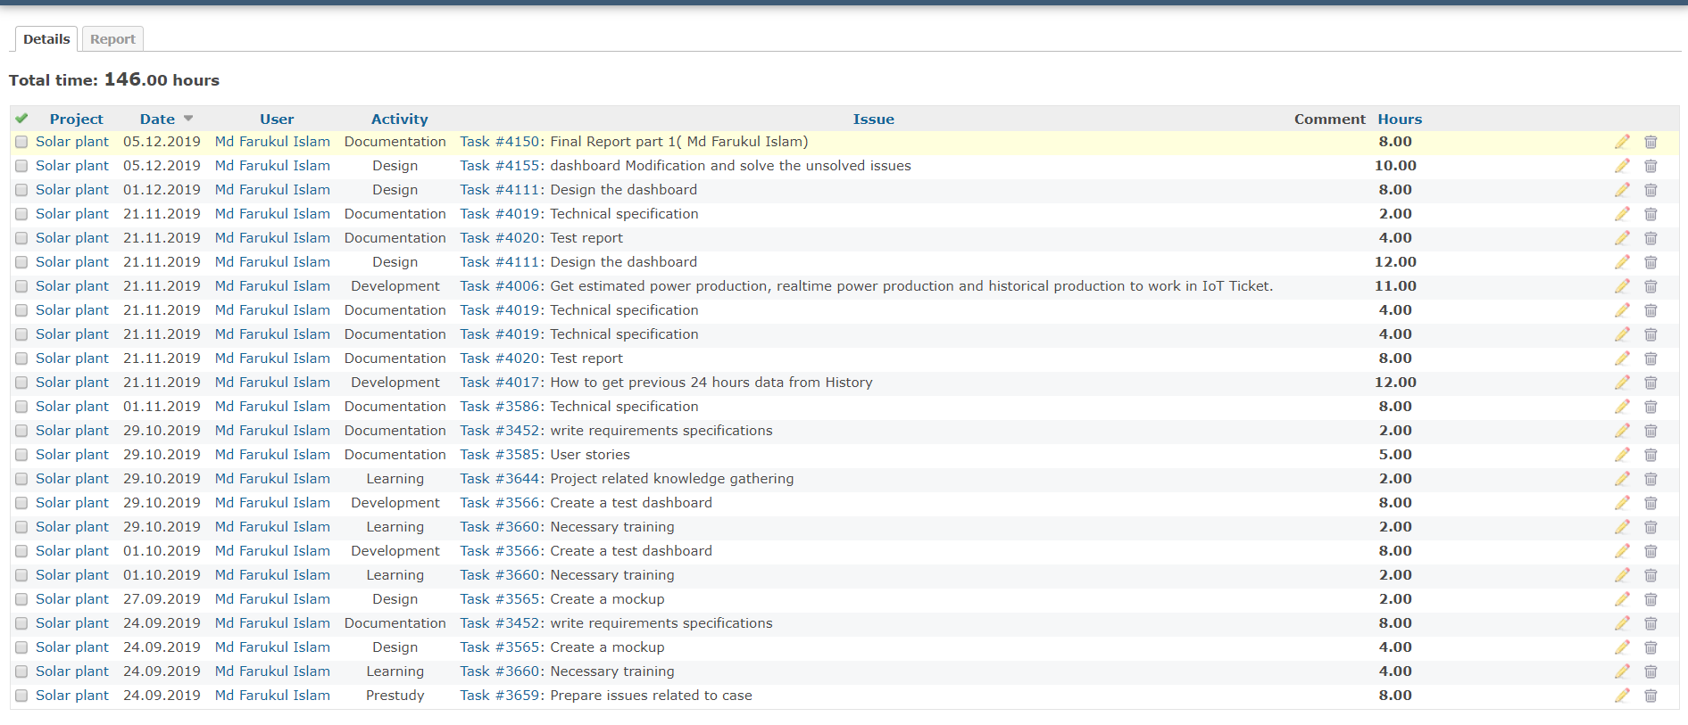

Total spent time by Albin Westerlund team leader and developer.

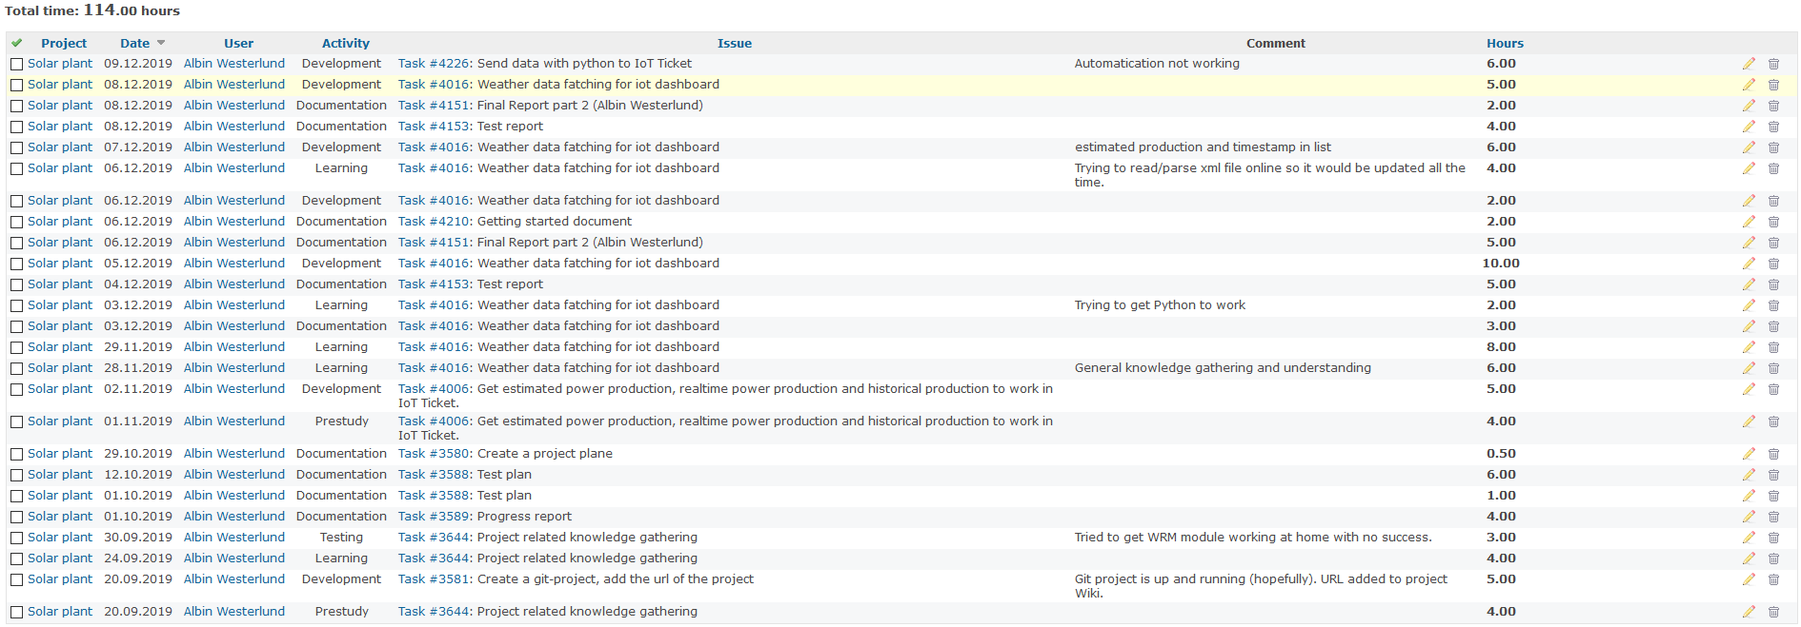

Total spent time by Carlos Martinez de la Riva Valdaliso team member and developer.

